[Date]

Application Engineering Development

Assignment - 3

Prathamesh Sahasrabuddhe

NUID: 002117703

Rohit Chouhan

NUID: 002191647

Vivek Sharma NUID: 002105272

**Application Engineering Development INFO-5100**

**Assignment -3**

|  |  |
| --- | --- |
| **TABLE OF CONTENTS** | |
|  | |
|  | **Page No.** |
| **Aim** | 3 |
| **Problem Definition** | 3 |
| **Problem Solution** | 3-5 |
| **User Interface Dashboard** | **IV** |
| **UML Diagram** | **V** |
| **Sequence Diagram** |  |
|  |  |

**Aim:**

Use software engineering techniques to improve the quality of education anywhere and hold people accountable for improving the quality of life through education, learning to learn, and feedback.

**Problem Definition:**

The institute faces universal competition which demands them to emphasize supervising and assessing the quality of education delivered. The Colleges should be considering the composition of courses proposed by a department with the existing real-time employment opportunities. For a learner, it is very vital to examine the course that is relevant to their area of interest and aligns with the industry standards. On the same note, even the university requires to observe a technique to quantify its performance enabling it to devise strategies to tackle its reputation. To address these problems, we aim to build a performance measurement solution to enable universities to measure the quality of the education they deliver to their students.

**Problem Solution:**

Integrated a new feedback system in which feedbacks are taken every year for five years since alumni pass out. Median package and satisfaction level in their current job because of their course taken are measured through various questions which are taken as ranking parameters to create graphs. These graphs will help the university to measure the quality of education they deliver to students and modify the curriculum respectively. We have taken feedback from the recruiters about the student employment to measure the student work performance on cooperative education. Students can see the course catalog before enrolling in the class to decide where they want to enroll in that course or not.

The current system is biased toward research, we have displayed following the Performance Graph based on Student/Alumni/Recruiter's feedback on their real time-work experience:

* University Reputation’s graph representation based on Alumni’s average package over the five years of time and their satisfaction percentage cumulative of each college.

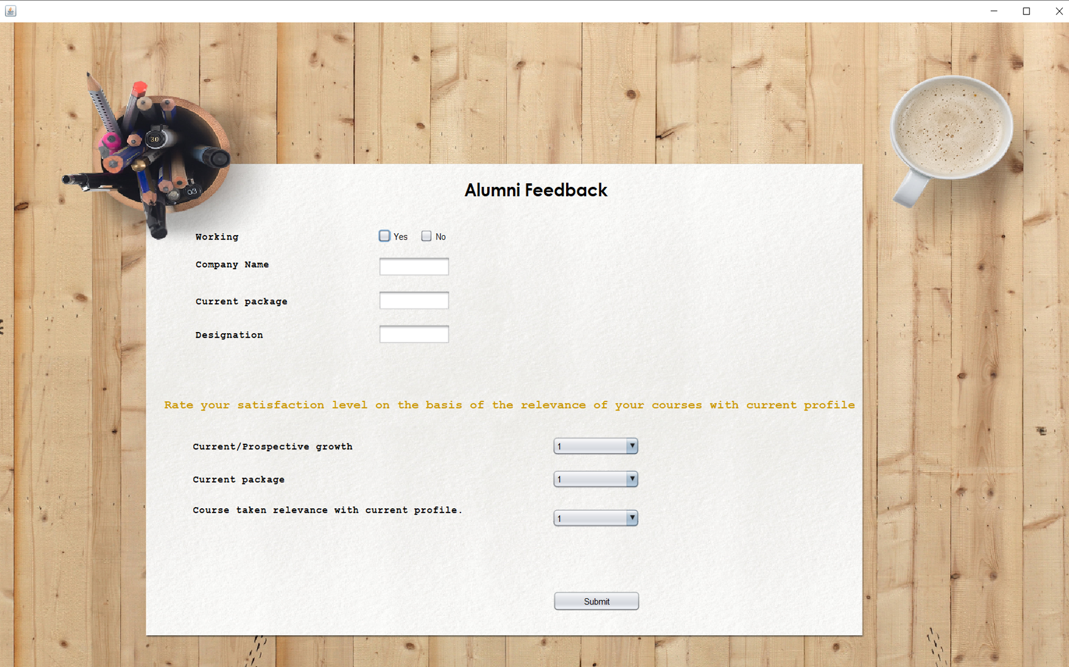

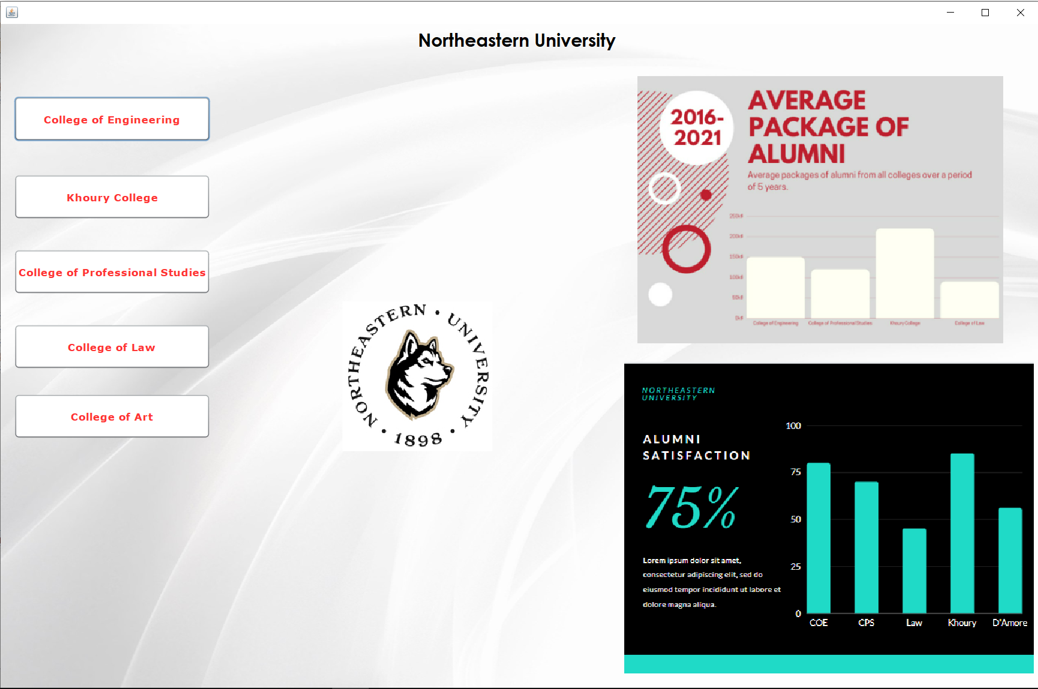

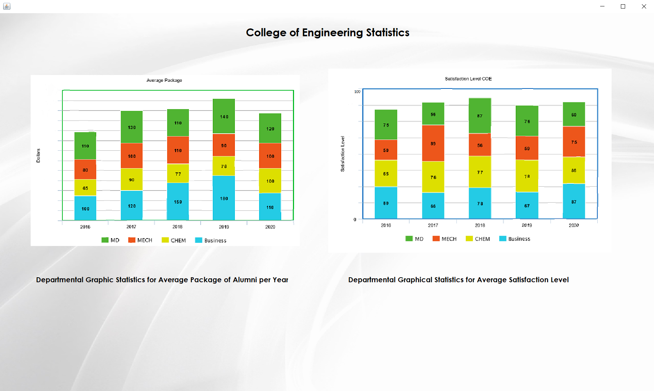

* Faculty Ratings based on student feedback, based on feedback, we will analyse whether the course curriculum needs any enhancement.

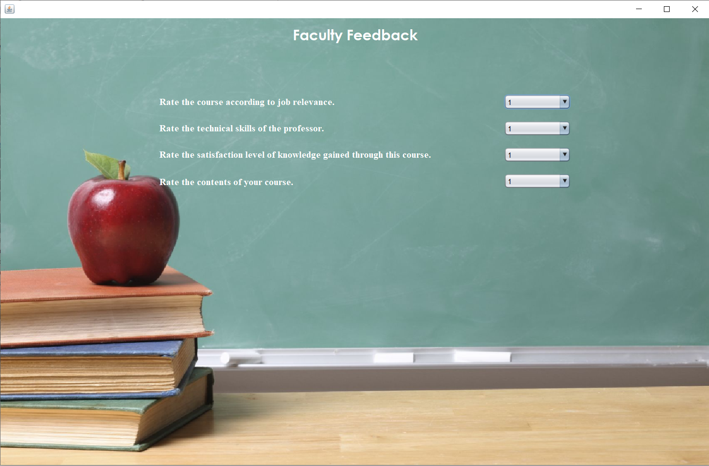

* Student Employment Performance Indicator based on the recruiter’s feedback for individual student working with them.

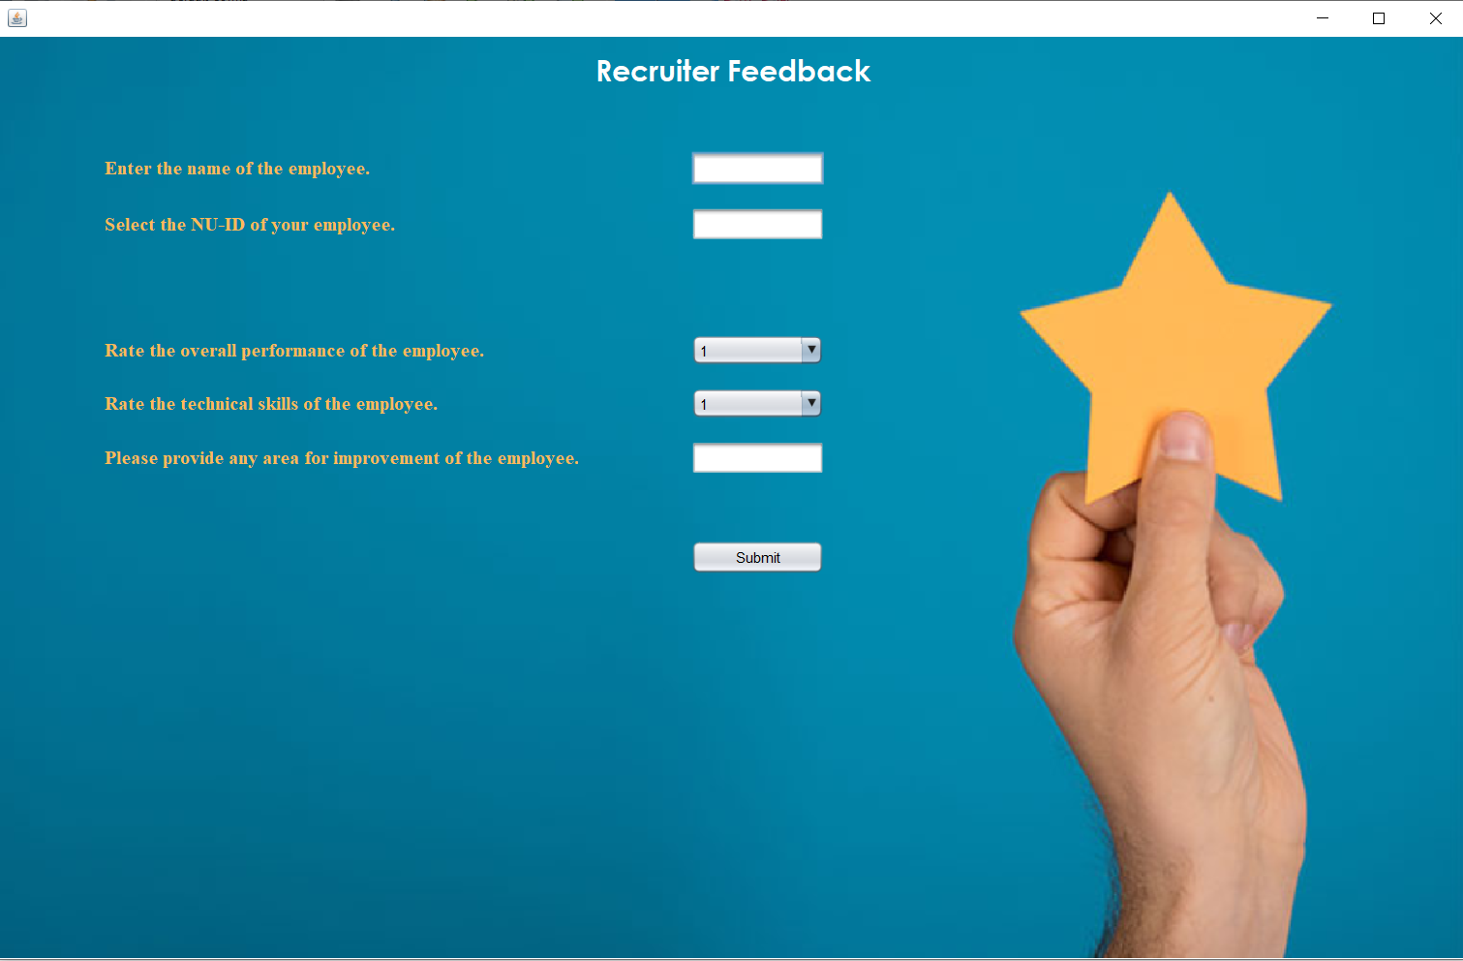

**Dashboard – UI:**

There are a total of three login interfaces for the end-user.

**University/Admin Login:**

The University Admin has access to each college statistic. The University admin can log in to view the statistics of every college under the university. To give a short summary of every college, there are two graphs displayed on the university dashboard itself to describe the overall statistics of all colleges.

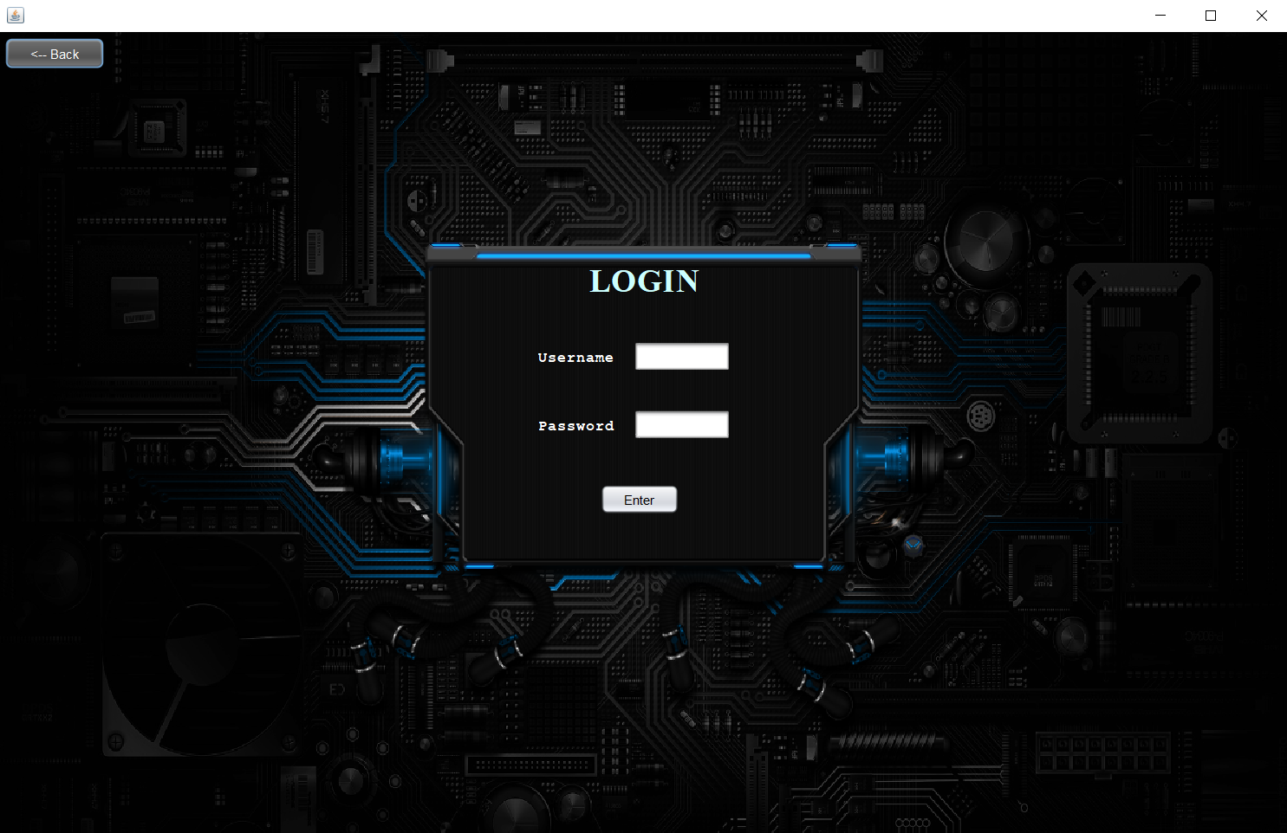

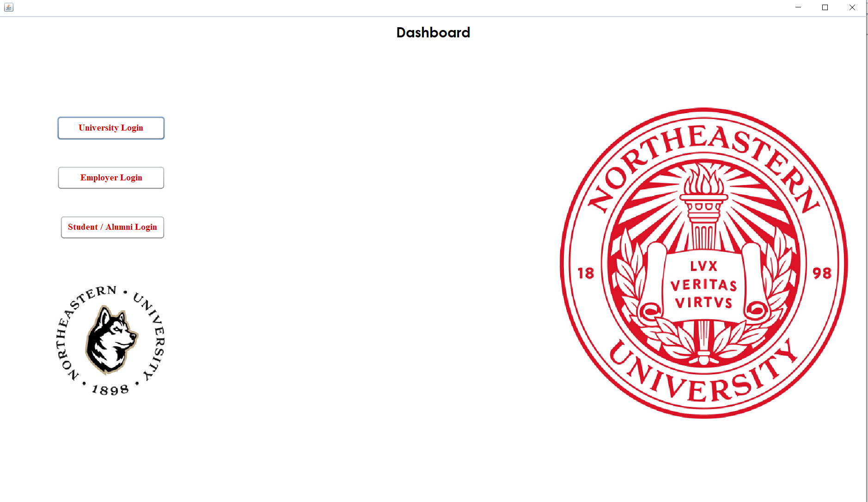

**Employer Login:**

The Employer Admin is used to take the feedback of the student from the Employer. The Employer can log in from their credentials into the system and add rank attributes for their employees who were students either for co-op or who turned out full-time after co-op.



**Student/Alumni Login:**

The Alumni Login is used to take feedback from the students who have passed out from the university and are currently working. The feedback is used to determine factors like current salary, current work field, and the satisfaction of present job. Current student can give feedback for the current or previous courses they enrolled in, based on their feedback we can analyze if any enhancement in the coursework is needed.

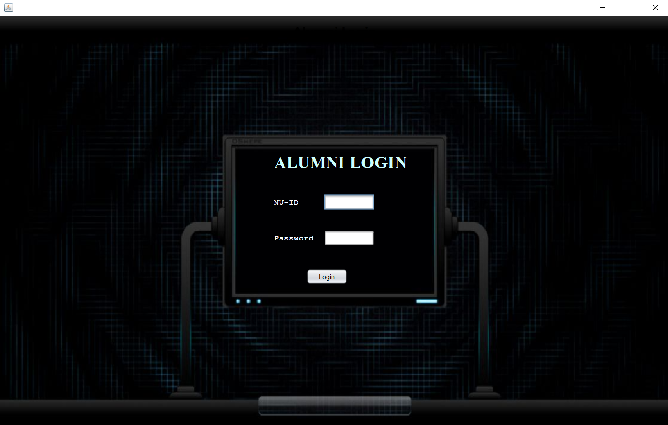

**UML Diagram:**

Class diagram with extended functionality showing ranking system and complete university model.

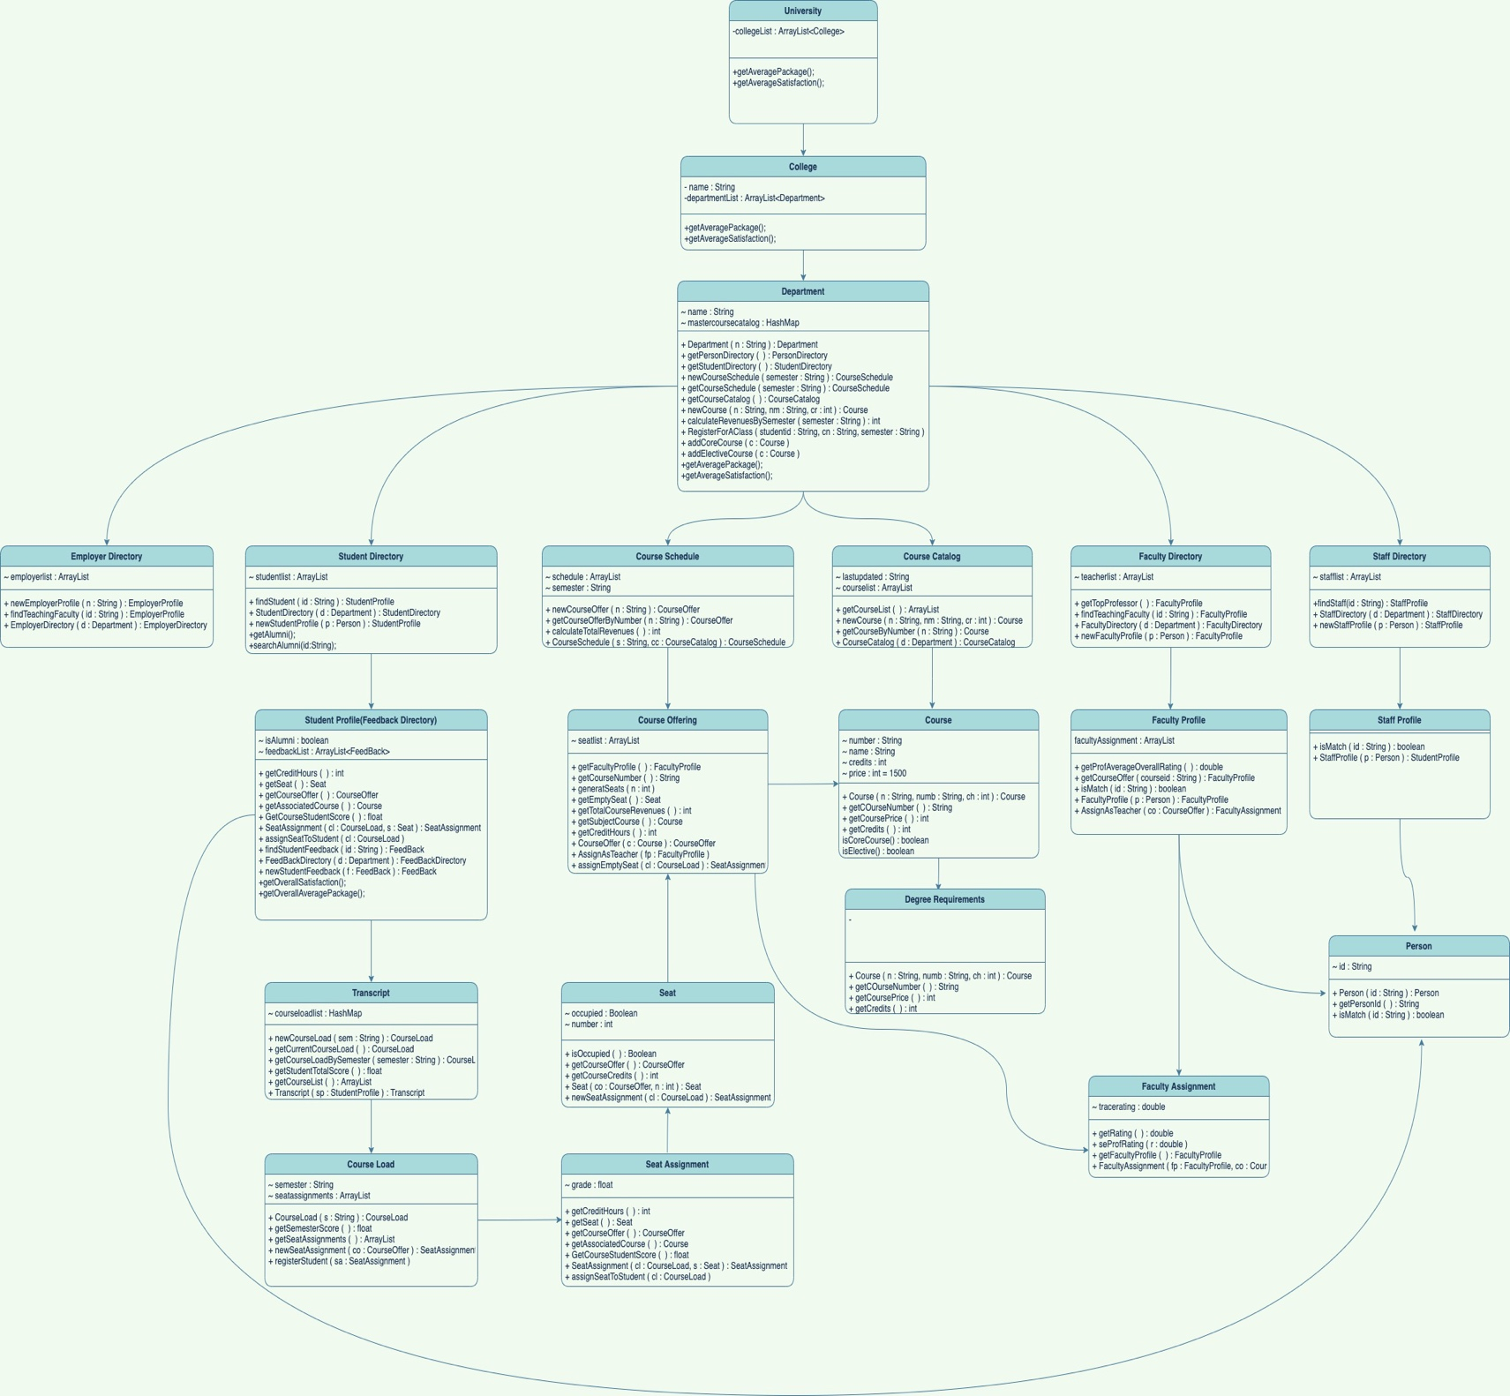 **Sequence Diagrams**

This provides a visual representation on how to navigate through our application.

**Sequence Diagram for Admin:**

**Sequence Diagram for Faculty:**

**Sequence Diagram for Employer:**

**Sequence Diagram for Student:**

